E1.

a) 2

b) ‘text 2’

c) ‘text 3 adaugat in subbloc’

d) 101

e) ‘text 1 adaugat un blocul principal’

f) 'text 3 adaugat in sub-bloc adaugat in blocul principal'

E2.

SELECT

o.zi,

COUNT(r.book_date) AS nr_imprumuturi

FROM

(

SELECT TO_DATE('01-NOV-24', 'DD-MON-YY') + LEVEL - 1 AS zi

FROM dual

CONNECT BY LEVEL <= 31

) o

LEFT JOIN rental r ON TRUNC(r.book_date) = o.zi

GROUP BY o.zi

ORDER BY o.zi;

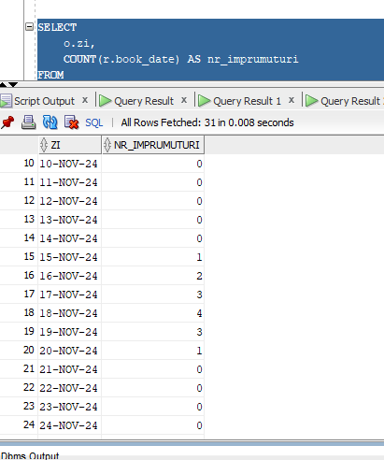

CREATE TABLE noiembrie_dpe (

id NUMBER PRIMARY KEY,

data DATE

);

DECLARE

v_data DATE := TO_DATE('01-NOV-24', 'DD-MON-YY');

BEGIN

FOR i IN 1..30 LOOP

INSERT INTO noiembrie_dpe (id, data)

VALUES (i, v_data);

v_data := v_data + 1;

END LOOP;

COMMIT;

END;

/

SELECT

o.data AS zi,

COUNT(r.book_date) AS nr_imprumuturi

FROM

noiembrie_dpe o

LEFT JOIN rental r ON TRUNC(r.book_date) = o.data

GROUP BY o.data

ORDER BY o.data;

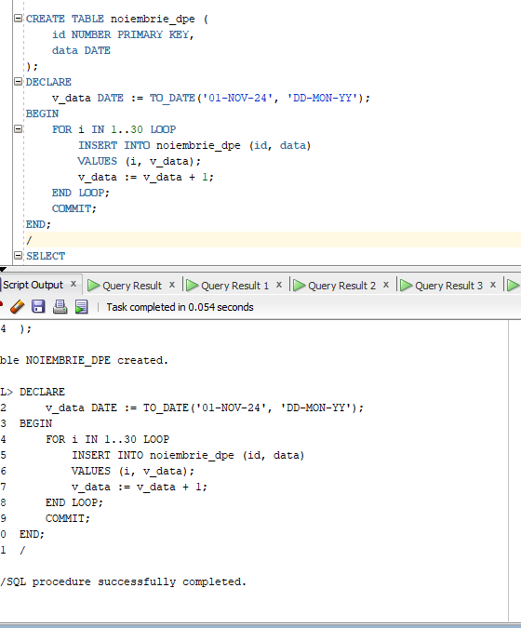

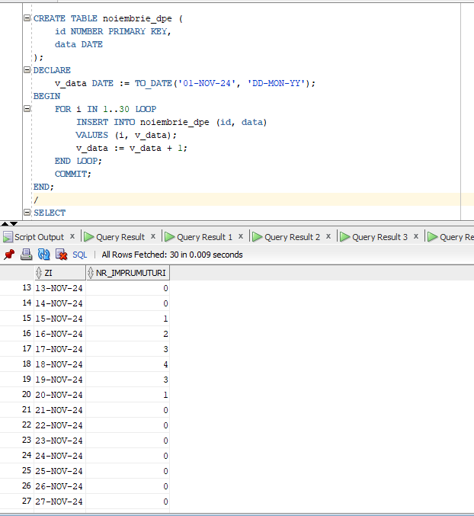

E3.

DECLARE

v_nume VARCHAR2(50);

v_membru_count INTEGER;

v_filme_imprumutate INTEGER;

BEGIN

v_nume := '&nume_membru';

SELECT COUNT(*)

INTO v_membru_count

FROM member

WHERE first_name = v_nume OR last_name = v_nume;

IF v_membru_count = 0 THEN

DBMS_OUTPUT.PUT_LINE('Nu exista nici un membru cu numele ' || v_nume);

ELSIF v_membru_count > 1 THEN

DBMS_OUTPUT.PUT_LINE('Exista mai multi membri cu numele ' || v_nume);

ELSE

SELECT COUNT(DISTINCT r.title_id)

INTO v_filme_imprumutate

FROM rental r

JOIN member m ON r.member_id = m.member_id

WHERE m.first_name = v_nume OR m.last_name = v_nume;

DBMS_OUTPUT.PUT_LINE(v_nume || ' ' || v_filme_imprumutate);

END IF;

END;

/

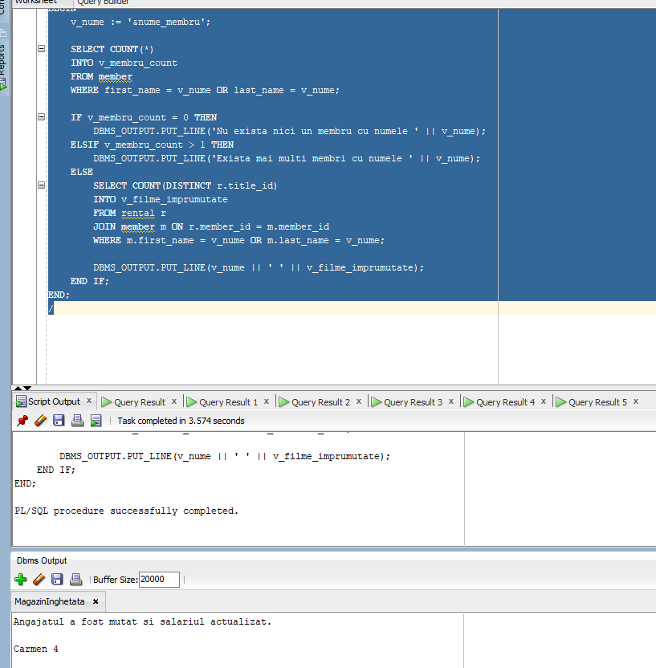

E4.

DECLARE

v_nume VARCHAR2(50);

v_membru_count INTEGER;

v_filme_imprumutate INTEGER;

v_total_filme INTEGER;

v_procent_imprumut INTEGER;

BEGIN

v_nume := '&nume_membru';

SELECT COUNT(*)

INTO v_membru_count

FROM member

WHERE first_name = v_nume OR last_name = v_nume;

IF v_membru_count = 0 THEN

DBMS_OUTPUT.PUT_LINE('Nu exista nici un membru cu numele ' || v_nume);

ELSIF v_membru_count > 1 THEN

DBMS_OUTPUT.PUT_LINE('Exista mai multi membri cu numele ' || v_nume);

ELSE

SELECT COUNT(DISTINCT r.title_id)

INTO v_filme_imprumutate

FROM rental r

JOIN member m ON r.member_id = m.member_id

WHERE m.first_name = v_nume OR m.last_name = v_nume;

SELECT COUNT(DISTINCT title_id)

INTO v_total_filme

FROM title;

v_procent_imprumut := (v_filme_imprumutate / v_total_filme) * 100;

DBMS_OUTPUT.PUT_LINE(v_nume || ' a imprumutat urmatorul numar de filme: ' || v_filme_imprumutate);

IF v_procent_imprumut > 75 THEN

DBMS_OUTPUT.PUT_LINE('Categoria 1: A imprumutat mai mult de 75% din titlurile existente');

ELSIF v_procent_imprumut > 50 THEN

DBMS_OUTPUT.PUT_LINE('Categoria 2: A imprumutat mai mult de 50% din titlurile existente');

ELSIF v_procent_imprumut > 25 THEN

DBMS_OUTPUT.PUT_LINE('Categoria 3: A imprumutat mai mult de 25% din titlurile existente');

ELSE

DBMS_OUTPUT.PUT_LINE('Categoria 4: A imprumutat mai putin de 25% din titlurile existente');

END IF;

END IF;

END;

/

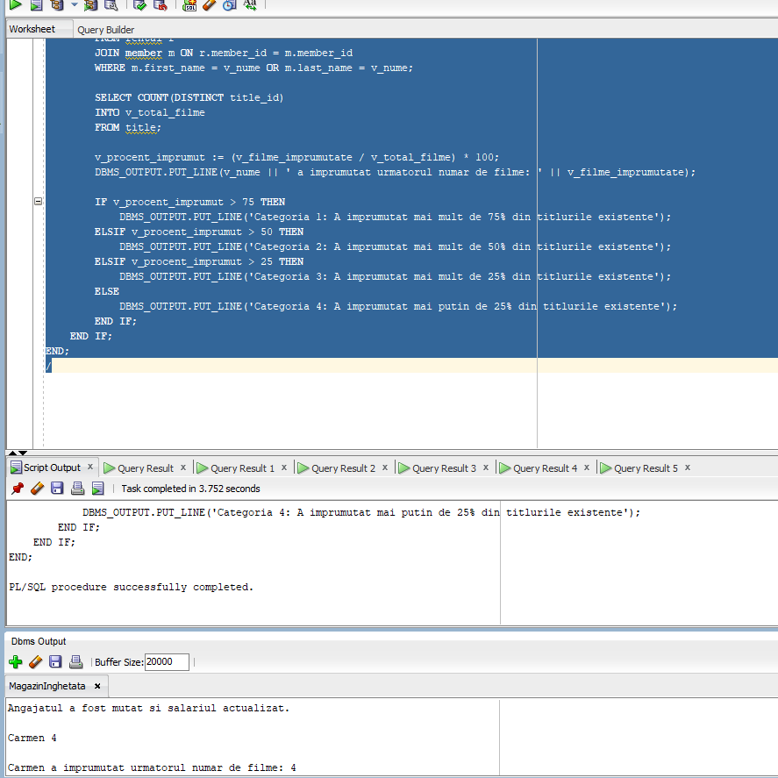

E5.

CREATE TABLE member_dpe AS

SELECT member_id,

first_name,

last_name,

address,

city,

phone,

join_date

FROM member;

-- Adaug coloana discount

ALTER TABLE member_dpe ADD discount NUMBER(5,2);

DECLARE

v_membru_id NUMBER;

v_filme_imprumutate INTEGER;

v_total_filme INTEGER;

v_procent_imprumut INTEGER;

v_discount NUMBER(5,2);

BEGIN

v_membru_id := &membru_id;

SELECT COUNT(DISTINCT r.title_id)

INTO v_filme_imprumutate

FROM rental r

JOIN member m ON r.member_id = m.member_id

WHERE m.member_id = v_membru_id;

SELECT COUNT(DISTINCT title_id)

INTO v_total_filme

FROM title;

v_procent_imprumut := (v_filme_imprumutate / v_total_filme) * 100;

IF v_procent_imprumut > 75 THEN

v_discount := 10;

ELSIF v_procent_imprumut > 50 THEN

v_discount := 5;

ELSIF v_procent_imprumut > 25 THEN

v_discount := 3;

ELSE

v_discount := 0;

END IF;

UPDATE member_dpe

SET discount = v_discount

WHERE member_id = v_membru_id;

IF SQL%ROWCOUNT > 0 THEN

DBMS_OUTPUT.PUT_LINE('Actualizarea discount-ului s-a realizat cu succes pentru membrul cu id-ul ' || v_membru_id);

ELSE

DBMS_OUTPUT.PUT_LINE('Nu exista nici un membru cu id-ul ' || v_membru_id);

END IF;

END;

/

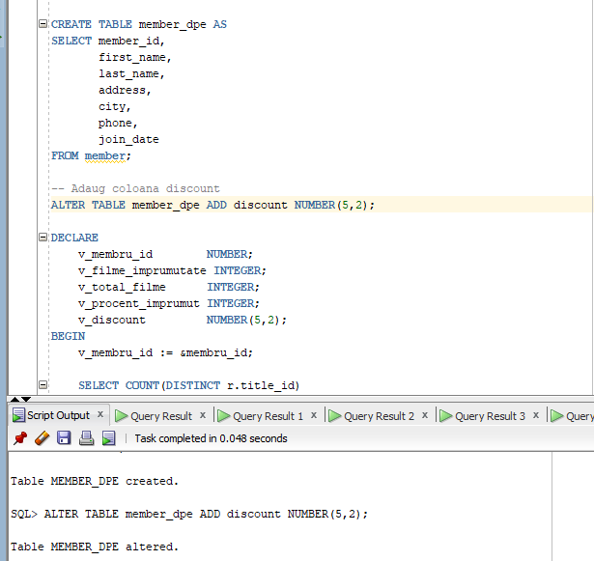

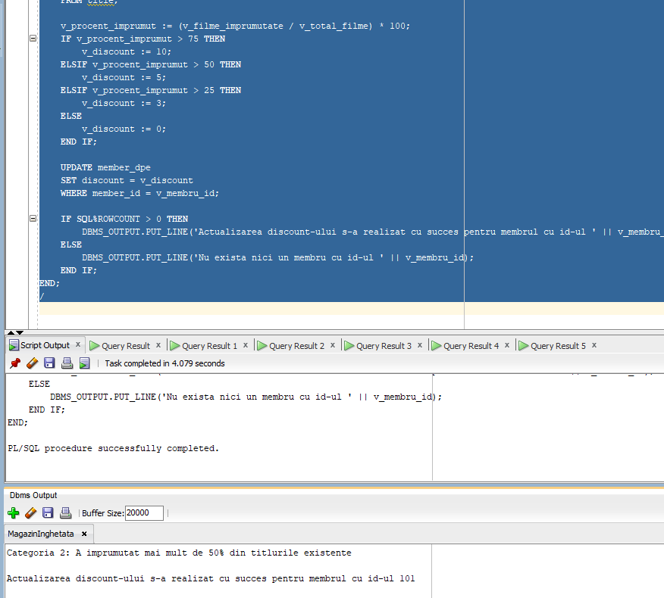

E6.

VARIABLE rezultat VARCHAR2(100);

BEGIN

SELECT NumeMagazin

INTO :rezultat

FROM Magazine m

JOIN Angajati a ON m.IDMagazin = a.IDMagazin

GROUP BY NumeMagazin

HAVING COUNT(a.IDAngajat) = (

SELECT MAX(employee_count)

FROM (

SELECT COUNT(*) AS employee_count

FROM Angajati

GROUP BY IDMagazin

)

);

DBMS_OUTPUT.PUT_LINE('Magazinul cu cei mai multi angajati este: ' || :rezultat);

END;

/

PRINT rezultat;

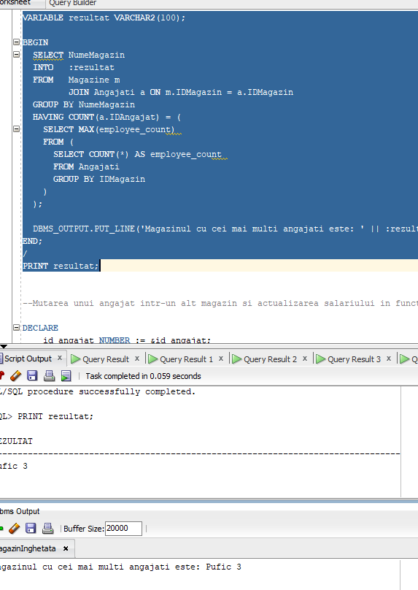

SET VERIFY OFF;

DECLARE

v_cod Angajati.IDAngajat%TYPE := &p_cod;

v_bonus NUMBER(8);

v_salariu NUMBER(8);

v_salariu_max NUMBER(8);

BEGIN

BEGIN

SELECT Salariu INTO v_salariu

FROM Angajati

WHERE IDAngajat = v_cod;

EXCEPTION

WHEN NO_DATA_FOUND THEN

DBMS_OUTPUT.PUT_LINE('Nu exista niciun angajat cu codul ' || v_cod);

RETURN;

END;

SELECT MAX(Salariu) INTO v_salariu_max

FROM Angajati;

-- Comparatia salariului curent cu procentele din salariul maxim

IF v_salariu < (v_salariu_max * 0.25) THEN

v_bonus := 0;

ELSIF v_salariu < (v_salariu_max * 0.50) THEN

v_bonus := 1000;

ELSIF v_salariu < (v_salariu_max * 0.75) THEN

v_bonus := 2000;

ELSE

v_bonus := 3000;

END IF;

DBMS_OUTPUT.PUT_LINE('Bonusul pentru angajatul cu codul ' || v_cod || ' este ' || v_bonus);

END;

/

SET VERIFY ON;

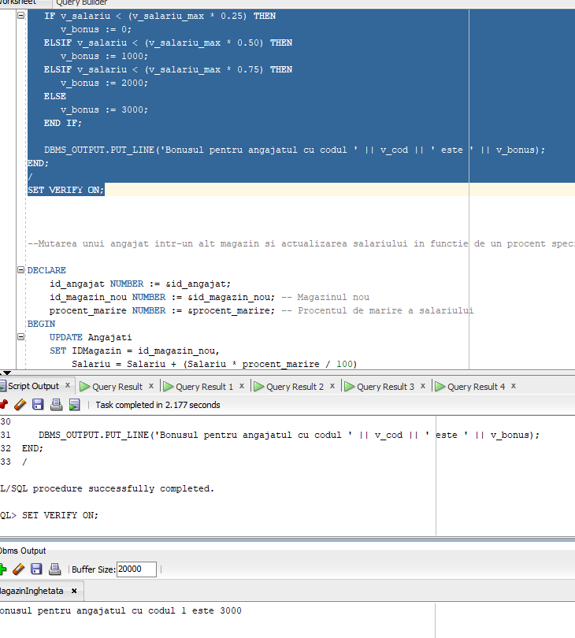

--Mutarea unui angajat intr-un alt magazin si actualizarea salariului in functie de un procent specific

DEFINE p_cod_sal = 1

DEFINE p_cod_mag = 3

DEFINE p_procent = 23

DECLARE

v_cod_sal Angajati.IDAngajat%TYPE := &p_cod_sal;

v_cod_mag Angajati.IDMagazin%TYPE := &p_cod_dept;

v_procent NUMBER(8) := &p_procent;

BEGIN

UPDATE Angajati

SET IDMagazin = v_cod_mag,

Salariu = Salariu + (Salariu * v_procent / 100)

WHERE IDAngajat = v_cod_sal;

IF SQL%ROWCOUNT = 0 THEN

DBMS_OUTPUT.PUT_LINE('Nu exista un angajat cu acest cod');

ELSIF SQL%ROWCOUNT > 0 THEN

DBMS_OUTPUT.PUT_LINE('Angajatul a fost mutat si salariul actualizat.');

END IF;

ROLLBACK;

END;

/

